**DSWD DROMIC Report #7 on the Coronavirus Disease (COVID-19)**

as of 23 March 2020, 6PM

**Situation Overview**

On 31 December 2019, a clustering of pneumonia cases of unknown etiology was reported in Wuhan, China. The outbreak was later determined to be caused by a new coronavirus strain that has not been previously identified in humans. On 30 January 2020, the Department of Health (DOH) confirmed the first case in the Philippines when a 38-year old female Chinese patient under investigation tested positive for COVID-19. On 12 March 2020 at 9PM, a Presidential Press Conference was conducted announcing the raising of the Philippine’s COVID-19 Alert Level System to Code Red Sublevel 2. The Chief Executive approved the imposition of Stringent Social Distancing Measures in the National Capital Region (NCR) for thirty (30) days effective 15 March 2020. On 16 March 2020, a Memorandum from the Executive Secretary was issued regarding Community Quarantine over the entire Luzon and Further Guidelines for the Management of the Coronavirus Disease 2019 (COVID-19) Situation.

*Source: DOH through the National Disaster Risk Reduction and Management Council (NDRRMC)*

**Status of Prepositioned Resources: Stockpile and Standby Funds**

The DSWD Central Office (CO), Field Offices (FOs), and National Resource Operations Center (NROC) have stockpiles and standby funds amounting to **₱1,992,235,824.76** with breakdown as follows (see Table 1):

1. **Standby Funds**

A total of **₱1,293,580,076.99** standby funds in the CO and FOs. Of the said amount, **₱1,253,367,735.97** is the available Quick Response Fund (QRF) in the CO.

1. **Stockpiles**

A total of **277,072 family food packs (FFPs)** amounting to **₱99,275,733.73**, and **other food and non-food items (FNIs)** amounting to **₱599,380,014.04** are available.

***Table 1. Available Standby Funds and Stockpiles***

|  |  |  |  |  |  |  |  |
| --- | --- | --- | --- | --- | --- | --- | --- |
| **OFFICE** | ***STANDBY FUNDS*** | ***FAMILY FOOD PACKS*** | | ***Other Food Items*** | ***Non Food Items*** | ***SUB-TOTAL (Food and NFIs)*** | ***Total STANDBY FUNDS & STOCKPILE*** |
| ***Quantity*** | ***Total Cost*** | ***Total Cost*** | ***Total Cost*** |
| **TOTAL** | 1,148,118,684.69 | 274,651 | 99,424,892.12 | 168,359,996.90 | 431,020,017.14 | 599,380,014.04 | 1,846,923,590.85 |
| **Central Office** | 1,110,896,338.67 | 0 | - | - | - | - | 1,110,896,338.67 |
| **NRLMB - NROC** | - | 61,498 | 22,310,440.00 | 25,033,896.34 | 196,090,074.48 | 221,123,970.82 | 243,434,410.82 |
| **NRLMB - VDRC** | - | 2,567 | 941,120.00 | 6,747,536.80 | 6,358,727.50 | 13,106,264.30 | 14,047,384.30 |
| **I** | 0.00 | 4,007 | 1,488,318.08 | 245,144.64 | 36,791,330.65 | 37,036,475.29 | 38,524,793.37 |
| **II** | 2,829,067.84 | 16,458 | 5,839,564.62 | 3,149,722.00 | 6,057,718.95 | 9,207,440.95 | 17,876,073.41 |
| **III** | 3,000,550.00 | 8,822 | 3,615,137.90 | 1,956,002.70 | 4,735,242.90 | 6,691,245.60 | 13,306,933.50 |
| **CALABARZON** | 3,000,000.00 | 12,050 | 3,929,189.60 | 1,213,850.00 | 8,639,451.49 | 9,853,301.49 | 16,782,491.09 |
| **MIMAROPA** | 1,451,652.18 | 30,615 | 13,776,750.00 | 5,339,530.60 | 6,886,713.04 | 12,226,243.64 | 27,454,645.82 |
| **V** | 3,000,000.00 | 18,538 | 5,716,656.94 | 5,550,788.00 | 31,924,347.16 | 37,475,135.16 | 46,191,792.10 |
| **VI** | 1,162,699.50 | 18,356 | 6,521,040.00 | 39,145,071.10 | 6,394,504.00 | 45,539,575.10 | 53,223,314.60 |
| **VII** | 3,000,000.00 | 22,120 | 5,439,600.00 | 5,698,008.45 | 7,814,979.35 | 13,512,987.80 | 21,952,587.80 |
| **VIII** | 3,000,550.00 | 2,084 | 780,812.28 | 2,658,560.88 | 12,351,635.08 | 15,010,195.96 | 18,791,558.24 |
| **IX** | 2,154,824.50 | 23,920 | 8,611,200.00 | 4,678,279.10 | 13,582,414.34 | 18,260,693.44 | 29,026,717.94 |
| **X** | 3,106,997.00 | 14,929 | 5,421,163.64 | 28,783,887.83 | 19,736,865.19 | 48,520,753.02 | 57,048,913.66 |
| **XI** | 2,506,000.00 | 13,864 | 5,495,273.68 | 10,094,107.00 | 30,036,909.02 | 40,131,016.02 | 48,132,289.70 |
| **XII** | 3,000,000.00 | 8,229 | 3,299,829.00 | 14,524,219.00 | 13,606,581.36 | 28,130,800.36 | 34,430,629.36 |
| **CARAGA** | 3,000,000.00 | 13,574 | 5,007,136.20 | 4,678,279.10 | 3,518,063.06 | 8,196,342.16 | 16,203,478.36 |
| **NCR** | 3,000,000.00 | 142 | 53,553.88 | 260,800.00 | 11,414,374.86 | 11,675,174.86 | 14,728,728.74 |
| **CAR** | 10,005.00 | 2,878 | 1,178,106.30 | 8,602,313.36 | 15,080,084.71 | 23,682,398.07 | 24,870,509.37 |

*Note: The Inventory Summary is as of 23 March 2020.*

*Source: DSWD-NRLMB*

**Situational Reports**

**DSWD-DRMB**

|  |  |
| --- | --- |
| **DATE** | **SITUATIONS / ACTIONS UNDERTAKEN** |
| 23 March 2020 | * The Disaster Response Management Bureau (DRMB) is on **BLUE** alert status. * The DRMB Operations Center (OpCen) is in 24/7 operation, to closely monitor and coordinate with DSWD Field Offices for significant updates on response operations relative to COVID 19. * Continuous provision of duty personnel on a 24/7 duty at the NDRRMC Operations Center. * Prepared and facilitated the approved Request for Sub-Allotment and Transfer of Funds to DSWD-FOs I and II amounting to ₱1,768,000.00 and ₱3,000,000.00 respectively. This is intended for the replenishment of the Field Office standby funds and procurement of stockpiles for disaster augmentation and in relation to COVID-19 Response Operations. * Prepared request for replenishment of QRF amounting to ₱662.5 million. * Prepared Request for Sub-Allotment to replenish standby funds of the following FO’s: * DSWD-FO CAR – 3 Million * DSWD-FO I - 3 Million * DSWD-FO MIMAROPA - ₱1,846,000.00 * DSWD-FO VI - ₱1,838,000.00 * Assisted in the preparation and editing of Social Amelioration Card (SAC). * Prepared Process Flow for the implementation of the SAC. * Prepared request for replenishment of QRF amounting to Php662.5M. |

**DSWD-NRLMB**

|  |  |
| --- | --- |
| **DATE** | **SITUATIONS / ACTIONS UNDERTAKEN** |
| 23 March 2020 6PM | * DSWD- NRLMB is currently preparing the DSWD Field Office Implementation Plans for distributions of Family Food Packs * The total augmentation request from DSWD NCR of **80,000 FFPs** have been received by DSWD NRLMB. Out of this, a total of **30,250 FFPs** have already been delivered. A total of **8,750 FFP** augmentation were provided today (March 24) to the following LGUs:  |  |  | | --- | --- | | LGU | Delivered FFPs Quantity | | * Las Piñas City | * 1,850 | | * Makati City | * 1,100 | | * Parañaque City | * 3,000 | | * Pasay City | * 2,400 | | * Taguig City | * 400 |  * DSWD-NRLMB coordinated with NDRRMC thru OCD on the request for provision of 10,000 bags of NFA rice for ongoing repacking of FFPs in DSWD NROC * DSWD-NRLMB coordinated the request of AFP CBRN Platoon posted as front liners for multivitamins with DOH HEMB. |
| 23 March 2020 6AM | * There is a total of 98,892 assessed poor households[1] within the National Capital Region (NCR). It is projected that a total of 988,920 family food packs (FFPs) is needed to sustain the poor households for the duration of the entire enhanced community quarantine. * Ongoing preparation of DSWD Field Office Implementation Plans for distribution of Family Food Packs (FFPs). * The total augmentation request from DSWD NCR is 80,000 FFPs which has been received by DSWD NRLMB. Out of this, a total of 7,300 FFPs have already been delivered to the following LGUs:  |  |  | | --- | --- | | LGU | Delivered FFPs Quantity | | * Taguig | * 2,600 | | * Marikina | * 2,100 | | * San Juan City | * 1,700 | | * Muntinlupa | * 900 |  * Coordinated with NDRRMC through OCD the request for provision of 10,000 bags of NFA rice for ongoing repacking of FFPs in DSWD NROC. * Coordinated/endorsed the request of AFP CBRN Platoon posted as front liners for multivitamins with DOH HEMB. |
| 22 March 2020 | * Continuous provision of duty personnel on a 24/7 duty at the NDRRMC Operations Center. * Ongoing preparation of DSWD Field Office Implementation Plans for distribution of Family Food Packs (FFPs). * Coordination with OCD on the possible mobilization of an MMDA disinfection tent for DSWD NROC as means of mitigation of contagion among personnel and volunteers working at the facility and visitor LGUs picking-up their requested FFPs. * Coordination with AFP on the request of NRLMB for volunteers on the repacking/hauling activities in response to the COVID-19 operations. * Coordination with DILG on the urgent request for relief assistance of the residents from Barangay Bancaan, Tabing-Dagat Naic Cavite. |
| 21 March 2020 | * Received the augmentation requests from DSWD-FO NCR for the following LGUs: * 80,000 FFPs for Pateros, Manila, Navotas and Muntinlupa City. Out of this, a total of 6,500 FFPs have already been delivered. * 20,000 FFPs for Quezon City, Malabon City and Valenzuela City. Out of this, a total of 7,600 FFPs have already been delivered. * Released 2,000 FFPs to DSWD-FO I. |

**DSWD-FO NCR**

|  |  |
| --- | --- |
| **DATE** | **SITUATIONS / ACTIONS UNDERTAKEN** |
| 22 March 2020 | * The FO-NCR had already coordinated with the 17 LGUs in Metro Manila through its respective Local Social Welfare and Development Office regarding the initial wave of FO-NCR’s food augmentation for stockpiling purposes. As of reporting time, the following family food packs were delivered to the LGUs, as follows:  |  |  |  |  |  | | --- | --- | --- | --- | --- | | **LGUs** | **Particular/Item** | **Cost Per unit** | **Quantity** | **Cost** | | Taguig City | Family Food Packs | 360 | 2,600 | 936,000.00 | | San Juan City | Family Food Packs | 360 | 1,700 | 612,000.00 | | Marikina City | Family Food Packs | 360 | 2,100 | 756,000.00 | | Muntinlupa City | Family Food Packs | 360 | 900 | 324,000.00 | | **SUB-TOTAL** | | | **7,300** | **2,628,000.00** | | **GRAND TOTAL** | | | **21,400** | **7,704,000.00** |   **COST OF ASSISTANCE PER LGU**   |  |  |  | | --- | --- | --- | | **LGU** | **Number of Food Packs** | **Cost of Assistance** | | Caloocan | N/A | N/A | | Las Piñas | N/A | N/A | | Malabon | 2,100 | 756,000.00 | | Makati | N/A | N/A | | Mandaluyong | N/A | N/A | | Manila | 2,200 | 792,000.00 | | Marikina | 2,100 | 756,000.00 | | Muntinlupa | 2,500 | 900,000.00 | | Navotas | 1,700 | 612,000.00 | | Parañaque | N/A | N/A | | Pasay | N/A | N/A | | Pasig | N/A | N/A | | Pateros | 1,000 | 360,000.00 | | Quezon | 3,800 | 1,368,000.00 | | San Juan | 1,700 | 612,000.00 | | Taguig | 2,600 | 936,000.00 | | Valenzuela | 1,700 | 612,000.00 | | TOTAL | 21,400 | 7,704,000.00 |   **Schedule of Delivery of Food Pack Augmentation to LGUs**   * The following are the target schedule for the continuation of the 1st wave of delivery of family food pack augmentation to the rest of the 17 Local Government Units:  |  |  |  | | --- | --- | --- | | **Local Government Unit** | **Schedule** | **Point of Delivery** | | Las Piñas City | March 23, 2020 (Monday) | Las Piñas City Hall | | Makati City | March 23, 2020 (Monday) | Brgy. Lapas, Covered Court, Makati City | | Parañaque City | March 23, 2020 (Monday) | Parañaque City Hall | | Pasay City | March 23, 2020 (Monday) | Pasay City Hall | | Caloocan City | March 24, 2020 (Tuesday) | To be updated | | Mandaluyong City | March 24, 2020 (Tuesday) | Mandaluyong City Hall | | Pasig City | March 24, 2020 (Tuesday) | BIR (within the compound of Pasig City Hall) |  * As to the number of the family food packs per LGU, the FO-NCR is continuously assessing and in close coordination with said LGUs with regard to the capacity of their respective warehouses. Logistics requirement particularly trucks or other vehicles for hauling and transporting the goods is also a major consideration. * Thus, the FO-NCR is continuously coordinating with Joint Task Force – National Capital Region (JTR-NCR) for possible provision of trucks / vehicles for hauling and transporting the goods. In the meantime, some of the Local Government Units have also committed to provide their trucks / vehicles for the same purpose.   **Issues and Concerns**   * Provision of Personal Protective Equipment (PPE) for the deployed responders, such as, but not limited to: * Warmers * Gloves * Alcohol and/or sanitizers * Provision of fuel allowance or reimbursement of gasoline expenses of the motorcycle riders group members of FO-NCR who assist in hauling and unloading goods and guide the transport and delivery of said goods to the identified point of delivery. |
| 21 March 2020 | * DSWD-FO NCR coordinated with the 17 LGUs in Metro Manila through its respective Local Social Welfare and Development Office regarding the initial wave of FO-NCR’s food augmentation for stockpiling purposes. As of reporting time, the following family food packs were delivered to the LGUs:  |  |  | | --- | --- | | **LGU** | **DELIVERED FFPs (Quantity)** | | **March 20, 2020** | | | Quezon City | 3,800 | | Malabon City | 2,100 | | Valenzuela City | 1,700 | | **Total** | **7,600** | | **March 21, 2020** | | | Manila City | 2,200 | | Navotas City | 1,700 | | Muntinlupa City | 1,600 | | Pateros | 1,000 | | **Total** | **6,500** |  * The NRLMB-CO assisted in the hauling and delivery of the said goods to the Local Government Units. Four (4) trucks were lent by said Office to FO-NCR to fast track the delivery process. * The hauling, delivery, and unloading of said goods were monitored by FO-NCR personnel composed of Disaster Response Management Division, the FO Motorcycle Riders’ Group and Quick Response Team members. * As to the number of the family food packs per LGU, the FO-NCR is continuously assessing and in close coordination with said LGUs with regard to the capacity of their respective warehouses. Logistics requirement particularly trucks or other vehicle for hauling and transporting the goods is also a major consideration. * Thus, the FO-NCR is continuously coordinating with Joint Task Force – National Capital Region (JTR-NCR) for possible provision of trucks / vehicles for hauling and transporting the goods. In the meantime, some of the Local Government Units have also committed to provide their trucks / vehicles for the same purpose. |
| 19 March 2020 | * DSWD-FO NCR established its Emergency Operation Center located at 2nd Floor, RD’s Office, FO-NCR, 389 San Rafael St. corner Legarda St., Sampaloc, Manila City. * DSWD-FO NCR with Secretary Rolando Joselito Bautista convened the 17 Local Social Welfare and Development Offices of the Local Government Units in Metro Manila to discuss the process of food augmentation and distribution. From said emergency meeting, the following were the highlights: * The 17 Local Government Units thru its Local Social Welfare and Development Offices will submit their respective Implementation Plan (IMPlans) on Food Augmentation to DSWD-NCR as soon as possible. The FO-NCR thru its Disaster Response Management Division shall consolidate the 17 IMPlans and forward it to Central Office. * The principal and alternate focals on food augmentation and distribution process of each LSWDO were already identified. * Distribution points of food augmentation were identified. |
| 17 March 2020 | * DSWD-FO NCR has activated its Quick Response Teams. All were advised to be on standby alert and to be ready for deployment once needed. * DSWD-FO NCR is conducting daily monitoring of emergencies or any eventualities using telephone, internet, cell phone, etc. through the Disaster Response Management Division Staff and Quick Response Team Leaders. * DSWD-FO NCR is closely coordinating with the following agencies in relation to COVID-19: * Metropolitan Manila Development Authority (MMDA); * Metro Manila Center for Health Development (MMCHD); and * Health Department of the 17 LGUs * The heads and the Health and Allied Services staff of DSWD-NCR who are stationed in the Centers/Residential Care Facilities (C/RCFs) were briefed to take necessary steps in the prevention, control, and mitigation of the Spread of Novel CoronaVirus Disease or COVID-19. The following were the actions taken by the C/RCFs: * Dissemination of IEC materials and hanging of posters about COVID-19; * Putting hand sanitizers or alcohol at the C/RCFs entrances; * Demonstration of proper hand washing technique; * Security personnel are advised to utilize thermal scanners to staff, clients, and visitors. * DSWD-FO NCR has also disseminated information re: 2019-COVID-19 during flag ceremonies through IEC Materials provided by the Department of Health (DOH). Thermal scanners are utilized by security personnel to all staff, clients, and visitors entering the premises of the FO. * Establishing Triaging or Assessment Area (for persons showing symptoms) through setting up of three (3) Closed-Tents in each of the 11 C/RCFs of FO-NCR. The said tents were put up on March 13, 2020. As of reporting time, there is no report of any staff or clients showing any symptoms of COVID-19. |

**DSWD-FO CAR**

|  |  |
| --- | --- |
| **DATE** | **SITUATIONS / ACTIONS UNDERTAKEN** |
| 23 March 2020 | * Delta Team 1 took over the Operations Center with ARDO Amelyn Cabrera as the Action Officer. * Rendered duty at the Emergency Operations Center and Incident Command Post. * Reconstitution of the DSWD Field Office Cordillera Administrative Region Quick Response Team for the Enhanced Community Quarantine * 18 Vehicles delivered FFPs, goods to all the Provinces of CAR within the two days. * DRMD on duty continuous coordination with partner agencies for the logistical concerns. * Continuous coordination with PDO II DRR focal in the Provinces and the QRT on duty and submit initial report. * SWAD QRT on duty continuously coordinates with LGUs and health workers on the updates regarding COVID-19. * A total of 42 volunteers composed of 4Ps, IPs, Solo Parents, Private Individuals and 19 came from uniformed personnel of Army and Army Reserve Command and 5 DPWH personnel also rendered their services for production of Family Food Packs at the Regional Resource Operations Center. * A total of 600 FFPs was delivered to the Province of ABRA on 23 March 2020 * A total of 104Boxes by 100’s of Sardines, 104Boxes by 100’s Corned Beef, 7,068 pieces of Coffee and 1,500 of Plastic Bags was delivered to Mountain Province. * The Provincial and Regional QRTs were already activated to continuously monitor the situation on ground. * Continuous coordination by the DRMD PDO III assigned in the PSWADTs with the LDRRMOs for updates. * Rapid Emergency Telecommunications Team (RETT) including the International Maritime/Marine Satellite (INMARSAT) equipment are on standby. * The Operations Center is on white alert in accordance with the alert level status of Cordillera Regional Disaster Risk Reduction and Management Council (CRDRRMC). * Identified possible production hubs within the region and coordinated with persons in authority to decide for such hubs. * Attended the Cordillera Regional Disaster Risk Reduction and Management Council Response Cluster Meeting. * Continuous repacking of family food packs. |
| 22 March 2020 | * A total of 24 volunteers composed of 4Ps, IPs, PWDs, Solo Parents, Senior Citizens, and Group of Women and 15 came from uniformed personnel of PNP, Army and Regional Community Defense also rendered their services for production of Family Food Packs at the Regional Resource Operations Center and Motorpool Production Hub located at City Camp, Baguio City. * SWAD QRT on duty continuously coordinates with LGUs and health workers on the updates regarding COVID-19. * DSW-FO CAR Emergency Operations Center is on **RED** alert status. * 500 FFPs will be delivered to the city of Baguio for relief augmentation. * Incident management team Cordillera was activated on March 17, 2020. |
| 20 March 2020 | * DSWD-FO CAR provided relief assistance to Benguet worth ₱199,875.00 while LGUs in Benguet and Abra have provided assistance to affected families/individuals amounting to a total of ₱532,760.00. |

**DSWD-FO I**

|  |  |
| --- | --- |
| **DATE** | **SITUATIONS / ACTIONS UNDERTAKEN** |
| 23 March 2020 | * Relative to the ongoing operations of the Regional Disaster Risk Reduction and Management Council 1 (RDRRMC1) and Regional Inter-Agency Task Force for the Management of Emerging Infectious Diseases (IATF – EID) for COVID-19, Mr. Zigfreid G. Lazo and Ms. Alyssa Joy O. Licudan attended the Regional Incident Management Team (IMT) Meeting at 2F, OCDRO1 Bldg., Aguila Road, Sevilla, City of San Fernando, La Union to organize the Regional IMT and its members who will respond to the effects of COVID-19. * The Field Office delivered 1,000 Family Food Packs (FFPs) from DSWD FO1 Warehouse B, Biday, City of San Fernando, La Union to Lingayen, Pangasinan. Likewise, a total of 850 bags of NFA rice from NFA San Juan and NFA Aringay, La Union were hauled in coordination with the Philippine Coast Guard (PCG) and Department of Public Works and Highways (DPWH). * Continuous updating of the official Facebook page of DSWD Field Office 1 and hotlines to contact for immediate response to the situation to inform the public about precautionary measures against COVID-19 * DSWD Field Office 1 is closely monitoring the areas affected by COVID-19 in coordination with the DOH, Provincial/ City/ Municipal Disaster Risk Reduction and Management Councils (P/C/MDRRMCs), and Provincial/ City/ Municipal Social Welfare and Development Offices (P/C/MSWDOs). * Continuous coordination was conducted with the Department of the Interior and Local Government Region 1 (DILG R1) for the breakdown of PUMs as basis for response to the requested augmentation. |
| 22 March 2020 | * The Command and General staff meeting was held at Panlipunan Hall, DSWD Field Office 1. Quezon Ave., City of San Fernando. La Union. The Regional Director provided updates regarding the DSWD Secretary's directives on the provision of assistance to the Local Governrnent Units (LGUs) based on the capacity of the Field Office.Hauling of 2,000 family food packs (FFPs) from DSWD-NRLMB intended for COVID-19 affected areas in the region. * Unloading of 2,000 Farnily Food Packs at the DSWD-FO I Warehouse B, Biday, City of San Fernando, La Union from DSWD National Resource and Logistics Management Bureau (NRLMB) intended for COVID-19 affected Provinces/ Municipalities/ Cities in the Region. * DSWD-FO continuously updating its official Facebook page and hotlines to contact for immediate response to the situation and inform the public about precautionary measures against COVID-19. * DSWD-FO I through its Disaster Response Management Division (DRMD) and the staff of Provincial Operations Offices are closely monitoring the areas affected by COVID-19 in coordination with DOH, Provincial/City/Municipal Disaster Risk Reduction and Management Councils (P/C/MDRRMCs), and Provincial/City/Municipal Social Welfare and Development Offices (P/C/MSWDOs). * DSWD-FO I received requests from 20 LGUs for FFPs and other support services to be provided to affected families due to the declaration of enhanced community quarantine in Luzon. Per coordination, the LGUs are now procuring and repacking goods for distribution to affected families. Likewise, a reporting template for LGUs was developed as attachment for their request. * DSWD-FO I coordinated with the Department of the interior and Local Government Region I (DILG R1) for the breakdown of PUMS as basis for response to the requested augmentation. |
| 20 March 2020 | * DSWD-FO 1 activated its Incident Management Team (IMT) for COVID-19, wherein the command and general staff attended a meeting at Panlipunan Hall, DSWD-FO I, Quezon Ave., City of San Fernando, La Union. * Hauling of 2,000 family food packs (FFPs) from DSWD-NRLMB intended for COVID-19 affected areas in the region. |

**DSWD-FO II**

|  |  |
| --- | --- |
| **DATE** | **SITUATIONS / ACTIONS UNDERTAKEN** |
| 18 March 2020 | * DSWD-FO II COVID-19 focal persons attended coordination meetings with their respective provinces re: Distribution of FOod to the affected families. * Attended RDRRMC meeting re: Development of PRotocols of all agencies for their respective offices to address COVID-19 concern. * DSWD-FO II ARDO and DRRS head will have coordination meetings with PNP/AFp re: Hauling and Distribution of FFPs to COVID-19 affected families. * Hauling of rice from NFA for repacking. * On-going repacking of FFPs. |
| 17 March 2020 | * DSWD-FO II MANCOM attended the emergency meeting through video conferencing relative to the directive of President Duterte on the Enhance Community QUarantine at the Regional Director’s Office yesterday, 16 March 2020. * DRMD prepared the IMPLAN relative on COVID-19. * DSWD-FO II conducted a meeting to discuss the Implementation Plan and submitted it on the same day. * Issued advisory to all DSWD-FO II staff/SWADTs/P/C/MATs re: precautionary measures for COVID-19. * COntinuous accounting of DSWD-FO II staff who travelled from December 2019 to present from places with confirmed cases and to submit to DOH CVCHD the list of monitoring and laboratory tracing. * All divisions/sections/units for DSWD-FO II prepared their work arrangement re: COVID-19. |

**DSWD-FO III**

|  |  |
| --- | --- |
| **DATE** | **SITUATIONS / ACTIONS UNDERTAKEN** |
| 23 March 2020 6PM | * Provision of 369 family food packs to the Municipality of Orani, Bataan; 609 FFPs to Malolos City, Bulacan; 1,800 FFPs to City of San Jose del Monte, Bulacan; and 2,400 FFPs to the Municipality of Floridablanca,Pampanga for the affected families under community quarantine.  |  |  |  |  | | --- | --- | --- | --- | | **PROVINCE** | **CITY/MUNICIPALITY** | **NO. OF FOOD PACKS** | **AMOUNT** | | BATAAN | ORANI | 369 | PHP 142,434.00 | | BULACAN | MALOLOS | 609 | PHP 235,074.00 | | BULACAN | CITY OF SAN JOSE DEL MONTE | 1,800 | PHP 736,242.00 | | PAMPANGA | FLORIDABLANCA | 2,400 | PHP 1,025,400.00 | | **TOTAL** |  | **5,178** | **PHP 2,139,150.00** |  * Provision of Personal Protective Equipment (PPEs), such as masks, gloves and alcohol, to frontliners. * Alerted all DSWD Provincial Extension Offices to continuously monitor the status of their respective areas. * Convened the RDRRMC Response Cluster to ensure on time delivery of government’s response efforts. * Activation of Emergency Operations Center (EOC) and establishment of Incident Management Team (IMT). * Coordination with AFP and PNP for the delivery and hauling of relief goods. * Requested standby vehicle to OCD-FO III for the delivery of goods. * Ongoing monitoring of the IMT on the situation and for other updates. * Ongoing repacking of family food packs. * Facilitated request of family food packs from various LGUs. * Mobilization of staff and volunteers for repacking of relief goods. * Emergency procurement of relief goods worth ₱3,000,000.00. * Twenty (20) AFP and PNP Personnel volunteered to repack family food packs. * Provision of P162,000.00 (P3,000.00 each) worth of Cash Assistance for the fifty four (54) stranded passengers at Clark International Airport (March 19, 2020) * Served twenty three (23) walk-in clients requesting for medical assistance thru AICS from March 17-20. * Requested National Resource Logistics and Management Bureau for fund augmentation of QRF worth P14,745,000.00. The said funds are intended for the purchase of food and non-food items including supplies needed as safety and precautionary measures against COVID-19. |
| 21 March 2020 | * On-going repacking of 1,700 family food packs. * Requested augmentation of 20,000 family food packs to NRLMB. * Provision of 2,400 family food packs to the Municipality of Floridablanca, Pampanga for the affected families under community quarantine. * Provision of 1,800 family food packs to the City Government of San Jose Del Monte, Bulacan. * Served twenty-three (23) walk-in clients requesting for medical assistance thru AICS from March 17-20. * Requested National Resource Logistics and Management Bureau for fund augmentation of QRF worth P14,745,000.00. The said funds are intended for the purchase of food and non-food items including supplies needed as safety and precautionary measures against COVID-19. |
| 20 March 2020 | * On 19 March 2020, DSWD-FO III provided ₱3,000.00 worth of cash assistance to 54 stranded passengers at Clark International Airport amounting to a total of ₱162,000.00. * Alerted all DSWD Provincial Extension Offices to continuously monitor the situation in their respective areas. * Convened the RDRRMC Response Cluster 3 to ensure on-time delivery of the government’s response efforts. * Activated Emergency Operations Center and established Incident Management Team. * Coordinated with AFP and PNP for the delivery and hauling of relief goods. * Requested standby vehicle from OCD3 for the delivery of goods. * Ongoing monitoring of the IMT on the situation and other updates. * Requested assistance from PNP for the security of the Regional Warehouse. * Provision of 1,800 FFPs to the City Government of San Jose del Monte, Bulacan for the affected families due to the ongoing community quarantine. * Various LGUs have already provided assistance to affected families due to community quarantine:  |  |  | | --- | --- | | **PROVINCE / CITY / MUNICIPALITY** | **AMOUNT** | | **TOTAL** | **29,588,451.00** | | **AURORA** | **248,451.00** | | Dinalungan | 248,451.00 | | **BULACAN** | **29,340,000.00** | | City of Malolos | 6,840,000.00 | | Guiguinto | 1,500,000.00 | | San Jose del Monte | 21,000,000.00 |  * Facilitate request of FFPs from various affected LGUs. * Mobilized staff and volunteers for repacking of relief goods. |

**DSWD-FO CALABARZON**

|  |  |
| --- | --- |
| **DATE** | **SITUATIONS / ACTIONS UNDERTAKEN** |
| 23 March 2020 | * The Field Office crafted its warehouse management guidelines in accordance with COVID-19 to ensure safety and security of employees during their tour of duty as well ensure the relief goods are in good quality and safe from any damage during hauling. |
| 22 March 2020 | * The QRTs are continuously monitoring the cases of reported PUIs, PUMs, and confirmed cases of COVID19 in their respective AOR. Reports are submitted to DRIMS-FO for consolidation and inclusion in the DSWD DROMIC Report. * DRMD developed communication channels limited to MANCOM and RMDC members to share information and areas for action. It is also a tool for immediate provision of technical assistance to the division and facilitate required documents for approval. * The EOC is in skeletal duty from Monday to Sunday to monitor the COVID19 cases and respond to the request for augmentation of LGUs. * The DRMD developed a GC including the PSWDOs for feedbacking, monitoring of LGUs submission of report and request for augmentation. Sharing of other significant information for action of the concerned LGUs. * DSWD FO IV-A through the DRMD is closely monitoring this outbreak, providing risk assessments, public health guidance, and advice on response activities to the Local Social Welfare and Development Offices. * Upon activation of the Response Cluster, DSWD FO IV-A and OCD IV-A is monitoring the response efforts of the response cluster. A video conference maybe set for all the response agencies for feedbacking * The Field Office is supporting other stakeholders on risk communication by sharing of key messages, community engagement, and hygiene promotion. All partners are encouraged to support in the sharing of correct information and to debunk ‘fake news’ by pointing at the use of only reliable and verified information sources. * The Regional Resource Operations Section (RROS) conducted disinfestation in the DSWD IV-A Warehouse in GMA, Cavite. It was assisted by the Sanitation Inspection Unit of GMA Cavite in preparation for the repacking of relief goods. * The Field Office crafted its Relief Distribution IMPLAN, priority is given to sectors that are affected by the implementation of the Enhanced Community Quarantine. * DSWD FO IV-A is using its communication channels to raise awareness among humanitarian populations of how to protect themselves from COVID-19. * The Field Office is crafting the warehouse management guidelines in accordance with COVID-19 to ensure safety of the repackers. * The members of the Regional and Provincial Quick Response Team (RPQRT) were placed on heightened alert level. They were advised to closely monitor and coordinate with the LGUs that may be needing augmentation from the Field Office. The Disaster Response Management Division (DRMD) advised the Local Social Welfare and Development Offices (LSWDOs) to closely monitor the cases of COVID-19 in their respective areas of responsibility, and provide necessary assistance. * DSWD-FO CALABARZON Emergency Operating Centre (EOC) was activated to effectively coordinate all urgent actions required for a swift response. * The Disaster Response Management Division (DRMD) developed and disseminated LGUs reporting template for COVID-19. DRMD is currently assessing LGUs reports where and how humanitarian operations are being disrupted to try to identify solutions as quickly as possible. * Disaster Response Cluster was activated on March 17, 2020. The response efforts are being orchestrated by the Department of Health (DOH) IV-A. * DSWD-FO CALABARZON through the DRMD is closely monitoring this outbreak, providing risk assessments, public health guidance, and advice on response activities to the Local Social Welfare and Development Offices. * The Field Office is supporting other stakeholders on risk communication by sharing of key messages, community engagement, and hygiene promotion. All partners are encouraged to support in the sharing of correct information and to debunk ‘fake news’ by pointing at the use of only reliable and verified information sources. * The Regional Resource Operations Section (RROS) conducted disinfestation in the DSWD IV-A Warehouse in GMA, Cavite. * The Field Office crafted its Relief Distribution IMPLAN, priority is given to sectors that are affected by the implementation of the Enhanced Community Quarantine. * The DRMD is working closely with LGUs to prepare response plans to ensure critical assistance and programs continues to reach those people most in need. * DSWD-FO CALABARZON is using its communication channels to raise awareness among humanitarian populations on how to protect themselves from COVID-19. |

**DSWD-MIMAROPA**

|  |  |
| --- | --- |
| **DATE** | **SITUATIONS / ACTIONS UNDERTAKEN** |
| 21 March 2020 | * As response to the wide scale local transmission of COVID-19, DSWD-FO MIMAROPA set protocols/guidelines pertaining to the Prevention, Control and Mitigation of the spread of the Coronavirus Disease – 19 (COVID-19) in the Regional/Provincial Offices including the MIMAROPA Youth Center. * Disaster Response Management Division and SWADT-Provincial Project Development Officers are alerted to monitor the daily local weather condition and any untoward incident to ensure provision of information to all concerned offices, divisions, sections, offices. * Alerted all P/C/M Quick Response Team in five (5) provinces of MIMAROPA to regularly monitor the situations in their areas. * All members of the R/P/C/M QRT together with the Rapid Emergency Telecommunications Team are on 24/7 on-call status for the possible activation of Operations Center, if needed. * Information and Communication Technology Management Unit (ICTMU) is on standby status to ensure a robust communication system. * Ensure that the Rapid Emergency Telecommunications Equipment (GX Terminal, BGAN Terminals and Satellite Phones) are in good condition and ready for deployment to areas that will experience potential emergencies. * Standby workforce in coordination with SWADT Offices and concerned LGUs on the management of stranded passengers in ports and terminals. * Ensured that there is an on-call truck available for delivery of goods and equipment to areas that will be affected. * Close coordination with the Office of Civil Defense (OCD) and RDRRMC MIMAROPA for any warning signal updates for monitoring purposes and response mechanism for areas that will be affected. |

**DSWD-FO V**

|  |  |
| --- | --- |
| **DATE** | **SITUATIONS / ACTIONS UNDERTAKEN** |
| 20 March 2020 | * DSWD-FO V MAT members from Tiwi, Albay; Nabua, Pasacao, and Balatan, Camarines Sur augmented in the repacking of relief goods at the LGU. * DSWD-FO V DRMD continuously monitoring COVID-19 updates and information. |
| 17 March 2020 | * DSWD-FO V QRTs were activated. * Regional Resource Operation Section of DSWD-FO V ensured the availability of family food packs and non-food items as need arises. * PAT and MAT members in the 6 provinces were activated and instructed to coordinate with the P/MDRRMOs, C/MSWDOs for COVID-19 reports and updates. * DSWD-FO V coordinated with LGUs for food ration requirements. |

**DSWD-FO VI**

|  |  |
| --- | --- |
| **DATE** | **SITUATIONS / ACTIONS UNDERTAKEN** |
| 22 March 2020 | * Summary of the Executive Orders issued by LGU in relation to the travel restriction in the region:  |  |  |  | | --- | --- | --- | | **LGU** | **EO No.** | **EO Name** | | Province of Aklan | EO No. 019  Series of 2020 | An executive order restricting the movement of the people and regulating the entry of goods as well as mandating social distancing measures for the management of the Corona Virus Disease 2019 situation in the province of Aklan | | | EO No. 19-A Series of 2020 | An order amending section 1 of executive order No. 19 by depeting paragraph C thereof. | | | Province of Capiz | EO No. 011 Series of 2020 | An order further strengthening strict quarantine procedures and restricting entry in the province of Capiz to prevent the spread of Corona Virus Disease 2019 | | | Province of Iloilo | EO No. 028-C Series of 2020 | An order further strengthening the imposition of quarantine procedures and disease prevention and control measures to protect the province of Iloilo against the Corona Virus Disease 2019 (COVID-2019) | | | Province of Negros Occidental | EO No. 20-15 Series of 2020 | An order implementing the closure of borders, ports and airports of Negros Occidental | | | Province of Guimaras | EO No. 29 Series of 2020 | An order for the temporary ban of commercial and private buses and vehicles from metro Manila entering the province of Guimaras | | | EO No. 32 Series of 2020 | An order temporarily suspending the entry and/or tours of guests from Metro Manila and those from other areas in the Philippines with localized COVID 19 transmission | | | EO No. 34 Series of 2020 | An executive order restricting and regulating the entry of persons in the province of Guimaras by reasons of 2019 Novel Corona Virus acute respiratory disease ( COVID 19) effective of March 17, 2020 and for other purposes | | | EO No. 35 Series of 2020 | An order for the suspension of classes in all levels in the province of Guimaras starting March 18, 2020 until further notice. | | | San Jose de Buenavista, Antique | EO No. 31 Series of 2020 | An Order executing further disease control measure for the protection of the province of Antique from Corona Virus disease 2019 | | | City of Bacolod | EO No. 21 Series of 2020 | An Order Declaring a General Community Quarantine in the City of Bacolod | | | City of Iloilo | EO No. 050 Series of 2020 | An executive order suspending and prohibiting the non-essential entry of persons travelling by sea within the city of Iloilo to contain and prevent the spread and/or local transmission of 2019 Novel Corona Virus Acute Respiratory Disease cases from 16 March 2020 at 12 midnight until 14 April 2020, and for other purposes | | | EO No. 055 Series of 2020 | An executive order implementing regulation ordinance no. 2020-056 series of 2020 in relation to the practice of enhancing community quarantine applicable to all commercial business, establishments, government offices and in residential areas, and for other purposes. | | | City of Roxas | EO No. 13 Series of 2020 | An executive order establishing boarder security and quarantine protocols in the city of Roxas as a preventive measure against Corona Virus Disease 2019 (COVID 19) | | | Province of Antique | E.O. 35 Series of 2020 | An executive order strengthening the measures to prevent and contain the spread and transmission of and to protect the people from infection with the Corona Virus Disease ( COVID 19) | |  * DSWD Regional Director instructed all staff to observe social distancing in the delivery of the different programs and services of the agency. FO Director is under quarantine as PUM for 14 days. * ARDA Evangeline Felecio conducted and emergency meeting to all Division Chiefs to strategize the social distancing measure without losing the quality of services the agency do provide to its clientele and observing the 40 hours/week work of employees. * Cancelled trips from Iloilo to Bacolod and Vice Versa. Roro is still in its operation giving permission to goods to be transferred. No travel restriction to Iloilo-Guimaras route. * DRMD Staff attended the 2 full days Contingency Planning on Emerging Diseases with RDRRMC Council. * Timely Online Monitoring of COVID 19 updates for information dissemination through DSWD VI –DRRM group chat and text blasts to DSWD Staff. * DSWD take part on the emergency meeting of selected member agencies of the Regional Disaster Risk Reduction and Management Council VI together with the governors of Western Visayas last March 16, 2020 lead by the OCD to discuss the on-going initiatives of the region to fight the Corona Virus Disease (COVID 19). DSWD presented possible augmentation through family food packs and Assistance to Individual Crisis Situation. * The management is exploring home based scheme to ensure the continuity of the agency’s services. * Social distancing is being implemented by the front line services of DSWD . In Antique POO, transactions are done through window and in Field Office VI, 1 meter distance is being implemented to ensure the safety of the workers and clients. * ARDA Evangeline conducted emergency meeting to all DCs on the preparation and submission of Implementation Plan to Central Office on COVID-19. As agreed, there will be one focal person per province coming from the DCs of FO VI to ensure continuity and delivery of DSWD safety nets to affected LGUs. DRMD will be the over all in charge division. SO will be released indicating TORs of the identified provincial focal person. * Activation of the Regional Incident Management Team- OCD. * Conducted MHPSS (through phone call) to 2 staff identified as PUM in the region. Close coordination to the identified PUM to provide MHPSS through daily phone communication * DSWD attended the 1st cluster meeting to ensure the harmonize response efforts of the government agencies against Corona Virus Disease 2019 (COVID-19). * Requested data from 6 provinces of Western Visayas on projected affected families of COVID -19. DSWD sent letters to PLGU with deadline on March 23, 2020 on the submission of data. * Disaster Response Management Division conducted a meeting with its section heads and discussed the strategies for prepositioning of family food packs, identifying of possible repacking station and head quarter per province and activation of the Quick Response Team. * DSWD SWAD team sat down with the task force meeting at the province of Antique and updated the task force on the preparedness for response of DSWD Antique. * DRMD is in close coordination with SWAD for the prepositioning on goods to Municipal Operations Office in every provinces. * DSWD VI submitted the Implementation Plan and WFP on COVID 19 last March 19, 2020 to Usec Neri and copy furnish to Usec Budiongan. * DSWD FO VI raised the “Red Alert” status and activated the Quick Response Team of DSWD VI. * DSWD SWAD team sat down with the Inter- Agency Task Force meeting on the preparedness for COVID 19 at the Province of Capiz last March 19, 2020. * SWAD Guimaras coordinated with the PDRRMO regarding mitigating plans for COVID 19. PDRRMO will call for a cluster meeting on March 24, 2020 to finalize the plan. * Delivery of family food packs for prepositioning to the Municipalities of Barbaza and Tobias Fornier, Antique and, Maayon and Jamindan, Capiz in partner with Philippine Red Cross for transport service. * DSWD had its RMANCOM meeting last March 21, 2020 and discussed the measures to be done on how to strictly observe the COVID 19 protocols such as social distancing and avoiding mass gatherings during the activities of the programs. * Meeting at DOH conference hall regarding the harmonization of the inter-agency task force together with the RDRRMC. * DSWD develop a Map using Quantum GIS with data of NHTS-PR and Number of PUMs per municipality for better analysis on family food pack distribution. |
| 20 March 2020 | * DSWD-FO VI DRMD is in close coordination with SWADTs for the prepositioning of goods to Municipal Operations Office in every province. * DSWD-FO VI raised its alert level status to RED and activated its QRT. |
| 17 March 2020 | * DSWD-FO VI Regional Director instructed all staff to observe social distancing in the delivery of different programs and services of the agency. * DSWD-FO VI ARDA conducted an emergency meeting with the Division Chiefs to strategize the social distancing measure without losing the quality of service. * DSWD-FO VI DRMD staff attended two (2) full days Contingency Planning on Emerging Diseases with RDRRMC. * Timely online monitoring of COVID-19 updates for information dissemination to DSWD-FO VI staff. |

**DSWD-FO VII**

|  |  |
| --- | --- |
| **DATE** | **SITUATIONS / ACTIONS UNDERTAKEN** |
| 22 March 2020 | * On 21 March 2020, The Office of the Presidential Assistant for the Visayas (OPAV) Sec. Michael Dino issued an advisory encouraging and enjoining all LGUs all throughout the Visayas to execute their respective Executive Orders pertaining to community quarantine, all in line with national government policies, particularly on the imposition of a 24-hour curfew for 65 years old and above and students, amid the COVID-19 situation.  |  |  |  |  |  | | --- | --- | --- | --- | --- | | **Cebu** | **#** | **Date Signed** | **Title** | **Effectivity** | | Bohol | EO 16 s2020 | 21-Mar-20 | An Executive Order Imposing a 24-hour Curfew on All Residents in the Province of Bohol Who Are Aged 65 and Above and All Below Aged 18 From Going Out of Their Homes in Order to Shield Them from the Effects of COVID-19 | 21 March - until further notice | | Cebu | EO 5-K s2020 | 21-Mar-20 | Additional Mitigation Measures to be Implemented by Local Chief Executives of Municipalities and Component Cities of the Province of Cebu  Salient Points: -24-hr province wide curfew covering pre-school, daycare, elementary, highschool, college, unemployed post-graduate students; and persons 65 years old and above -stricter social distancing in terminals, restaurants, public/private transport |  | | Negros Oriental | EO 21 s2020 | 3/16/2020 | An Order Declaring A General Community Quarantine in the Entire Province of Negros Oriental | 17 March – 14 April | | Siquijor | EO 16-A s2020 | 3/20/2020 | An Order Enforcing Necessary Measure and Amendment as Addenda to Executive Order No. 16, series of 2020 |  | |
| 20 March 2020 | * DSWD-FO VII remains committed to its mandate to assist LGUs as they address the food and other basic requirements of their constituents in times of emergencies. Field Offices are ordered to coordinate with LGUs in identifying target beneficiaries, distribution points, and strategies to be undertaken to ensure the smooth distribution of goods. * DSWD-FO VII coordinated with its partners such as the Philippine National Police (PNP) and the Armed Forces of the Philippines (AFP) for the hauling and delivery of family food packs to LGUs. * Procurement is on-going for rawer materials using DSWD-FO P6.6M standby funds which will be able to produce 15,550 more FFPs. By then, at least 40,990 packs will be made available as support to LGUs. * DSWD-FO VII has requested an additional P26M from the Central Office for the purchase of raw materials for repacking, which can produce at least 60,000 more family food packs. * On 14 March, DSWD City Action Team in Lapulapu City distributed food packs as response to the request of the City government for the provision of assistance to displaced workers in 14 barangays due to the COVID-19 scare. * DSWD initially released 2,619 family food packs or P942,840.00 worth of assistance. * DSWD-FO VII received letter requests from five (5) local government units – San Miguel, Bohol; Madridejos, Sta. Fe and Lapulapu City in Cebu; and in Valencia, Negros Oriental. Total requests already reached to 30,000 FFPs, so far. * The Response Section of the Disaster Division is currently writing a letter reply to the LGUs requesting for supporting documents, to help the team in the review and assessment. * Participation/attendance to coordination meetings called by the Inter-Agency Task Force on Managing Emerging Infectious Diseases (IATF-MEID7), Regional DRRM Council 7 (RDRRMC7) and special meetings by the Cebu Provincial Office and the Office of the Presidential Assistant for the Visayas (OPAV) Secretary Michael Lloyd Dino. |
| 17 March 2020 | * On 17 March 2020, a coordination meeting was held organized by the Inter-Agency Task Force on Managing Emerging Infectious Diseases (IATF-MEID7) and Regional DRRM Council 7 (RDRRMC7) re Presentation on Draft Joint Response Plan of IATF-MEID7-RDRRMC7 for Management of Emerging Infectious Diseases for Central Visayas 2020. DSWD-7 was represented by Josephine Belotindos, Disaster Response Management Division Chief. * DSWD-7 RD Rebecca Geamala attended a meeting yesterday, 16 March called for by the Presidential Assistant for the Visayas Secretary Michael Lloyd Dino on the readiness of the Response Cluster for COVID-19. He asked on the status of available family food packs in the region to ensure that there are enough food packs to be distributed to indigent and displaced workers, should the need arise. RD Geamala assured OPAV that DSWD has prepared sufficient food packs, and more had already been procured and ready to be individually packed by the DSWD personnel. * On 16 March, DSWD-7 ManComm discussed the FO guidelines in response to the issuance of Advisory No.1 by the Secretary, whereby a work from home arrangement is being considered. Personnel who meets agreed conditions, such as those undergoing self-quarantine, those with mild symptoms of cough, colds and fever and those who cannot go back to their area of assignment due to LGU restrictions imposed – are to avail of the work from home arrangement after a Special Order/Memorandum is issued. To date, a total of 54 personnel are undergoing self-quarantine including ARDO Shalaine Marie Lucero. Number is expected to increase, particularly field staff who are affected by the travel restrictions imposed by their Province/LGU area of assignment. * Once approved, the FO will be following the four-day work scheme. Some staff will be reporting on Mondays through Thursdays while others on Tuesdays through Fridays. Staff will render duty for 10 hours/day. * Both internal/external trainings, workshops, seminars, conferences and travels are suspended except for those coordination meetings in relation to COVID-19 discussion and response operations. ICT has encouraged google meet as an alternative meeting platform. * Hiring of staff will also be suspended for the duration of the quarantine period implemented in the Province. * The Crisis Intervention Section already has 1 thermal scanner. One of the 5 centers/residential care facilities managed by DSWD-7 also has 1 thermal scanner. Additional five scanners will be available soon. * All DSWD-FO VII personnel are required to wear masks, observe social distancing and proper hand washing. Hand soaps were provided in comfort rooms, alcohols placed in entrances, disinfectant sprays distributed, security guards wearing surgical masks and gloves, among others. |
| 14 March 2020 | * DSWD-FO VII through the Lapu-Lapu City Action Team distributed family food packs as response to the request of the city government for the provision of assistance. |

**DSWD-FO VIII**

|  |  |
| --- | --- |
| **DATE** | **SITUATIONS / ACTIONS UNDERTAKEN** |
| 23 March 2020 | * DSWD-FO VIII already activated Quick Response Team (QRT) and Provincial/City/Municipality Action TEams to closely coordinate and gather data at the LGUs and other partner agencies/offices. * Attended the Response Cluster Meeting to discuss updates, issues and concerns in relation to response activities on COVID-19. * DSWD-FO VIII officials conducted series of meetings to discuss precautionary preventive measures and protocols on COVID-19 to ensure the safety of clients and employees in this time of crisis situation. * Social Media Platforms were utilized to help in providing guidance through Effective Information, Education and Communication (IEC) Materials to clients and employees aside from the issued memorandum. * DSWD-FO VIII is in close coordination with the Health Cluster Member Agencies by attending regularly on meetings to keep updated on the current health issues and concerns. |

**DSWD-FO IX**

|  |  |
| --- | --- |
| **DATE** | **SITUATIONS / ACTIONS UNDERTAKEN** |
| 23 March 2020 6PM | * Continuous repacking of goods to maintain the required 30,000 family food packs at any given time. * The Disaster Division has already submitted a request for replenishment of the QRF Calamity Fund. * Activated the QRT started yesterday March 20, 2020 with 7 members per team per day composed of a Team Leader/or with Asst. Team Leader; two staff assigned for Food and non-food; one in-charge for communication &amp; reporting; one IT staff and two drivers. * All members of DSWD Quick Response Team of the Region are on-call status during the quarantine period. * The Regional Resource Operations Section of DSWD IX transported 1,200 Family Food Packs to SWAD-Pagadian Warehouse for stockpile. * The Provincial Action Teams (PATs) are in close coordination with the Local Government Units (LGUs) under their Area of Responsibility (AOR) using all means of communication such as social media and thru phone calls/texts for any possible augmentation support relative to COVID-19. Also, Project Development Officers of Disaster Response Management Division assigned in the provinces are taking into consideration the protocols implemented of LGUs re COVID-19 in order not to compromise the health of the public and our employees who provide frontline services. * Inspection of DSWD – DRRMD warehouse by DSWD FO-IX OIC Regional Director Fatima S. Caminan and DSWD-FO IX DRRS Sitti Aisa S. Askalani at around 1100 hrs, March 22, 2020. |
| 21 March 2020 | * Disaster Division also released 200 FFPs (131 for Lantawan, Basilan) and the remaining 69 FFPs were placed at Field Office IX intended for walk-in clients for food assistance. * Activated the QRT started yesterday March 20, 2020 with 7 members per team per day composed of a Team Leader/or with Asst. Team Leader; two staff assigned for Food and non-food; one in-charge for communication & and reporting; one IT staff and two drivers. |
| 20 March 2020 | * DSWD-FO IX coordinated with Gen. Cirilito Sobejana and the Philippine Coast Guard to ferry the relief items to Sibakil Island, Basilan. The relief items are intended for the 134 Filipino returnees from Sabah, Malaysia who are stranded within the vicinity of Lantawan, Basilan due to the implementation of enhanced community quarantine. They will be temporarily transferred to Sibakil Island. |

**DSWD-FO X**

|  |  |
| --- | --- |
| **DATE** | **SITUATIONS / ACTIONS UNDERTAKEN** |
| 23 March 2020 | * DSWD-FO X - DRMD Division Chief was in constant meeting with the regional director for discussion on Quick Response Team and Operational Centers activation. * Initial coordination with the LGU was put into place regarding preparation, guidelines and protocol for possible relief distribution. * Augmented staff members along with Cash for Work beneficiaries function together in repacking Family Food Packs in preparation for possible relief distribution. * Disaster Response and Management Division staff is on standby for further directives. |

**DSWD-FO XI**

|  |  |
| --- | --- |
| **DATE** | **SITUATIONS / ACTIONS UNDERTAKEN** |
| 23 March 2020 | * DSWD-FO XI provided 3,350 Family food packs to the COVID-19 affected families in 2 Barangays in Davao City. Total amount of assistance is ₱1,327,839.50. |
| 21 March 2020 | **Quick Response Teams (QRTs)**   * Activated DSWD FO – XI Quick Response Team composed of 8 teams with 12 members. Each team is ready and available for deployment should the need arise.   **Assets**   * DSWD FO – XI has 20 vehicles on standby, 5 of which are ambulances stationed at the residential care facilities. These vehicles are ready to be used in cases of necessity.   **Precautionary Measures**   * Activation of the Field Office’s and RPMO’s (SWADTs, PATs, MATs, CATs) Quick Response Team as “On-Call Duty” during the observance of the Holy Week; * Inter-office memorandum was issued to guide all staff and contribute to the prevention, control and mitigation of the spread of covid-19; * Advisory to external partners and service providers was also issued to conduct their transaction online; * Close coordination with all SWADOs as well as with PSWDOs/CSWDO/MSWDOs for monitoring of the situations in the different parts of Davao Region. Personnel in the warehouse are also on alert mood to ensure the readiness to dispatch relief goods (food and non-food items) at any given time; * Availability of Disaster Wing Van, Vehicles and Drivers in the event of a Relief Operation. * Close coordination with the Office of Civil Defense (OCD) XI for monitoring purposes and response mechanisms. * Coordination with staff rendering skeletal duty in the DRMD office for any incident that require to be reported |
| 21 March 2020 | * DSWD-FO XI provided 3,500 Family Food Packs to the affected families of COVID-19 in Davao Oriental Province. Total amount of assistance is ₱1,387,295.00. * DSWD-FO XI provided 3,200 Family food packs to the COVID-19 affected families in 2 Barangays in Davao City. Total amount of assistance is ₱1,268,384. |
| 20 March 2020 | * DSWD-FO XI closely coordinated with all SWADOs as well as with P/C/MSWDOs for monitoring of the situation in the different parts of Davao Region. * Personnel manning in the warehouse were alerted to ensure the readiness of dispatching food and non-food items and ensured that relief goods are readily available at any given time. * DSWD-FO XI ensured availability of wing van, vehicles and drivers in the event of a Relief Operation. * DSWD-FO XI closely coordinated with the Office of Civil Defense (OCD) XI for monitoring purposes and response mechanism. * DSWD-FO XI established coordination with staff rendering skeletal duty at the DRMD office in case there are disaster incidents that require to be reported. |

**DSWD-FO Caraga**

|  |  |
| --- | --- |
| **DATE** | **SITUATIONS / ACTIONS UNDERTAKEN** |
| 23 March 2020 | * Community quarantine are hereby declared in the following LGUs, to wit:  |  |  |  | | --- | --- | --- | | **Province** | **City/Municipality** | **Legal Basis** | | Agusan del Norte | Province Wide | E.O. No. 018, s. 2020 dated March 17, 2020 | | Butuan City | E.O. No. 019, s.2020 dated March 17, 2020 | | Buenavista | E.O. No. 020, s.2020 dated March 11, 2020 | | R.T. Romualdez | E.O. No. 15 | | Agusan del Sur | Province Wide | E.O. No. 13-2, s.2020 dated March 16, 2020 | | Bayugan City | E.O. No. 063, s.2020 dated March 15, 2020 | | Surigao del Sur | Province Wide | E.O. No. 014, s.2020 dated March 17, 2020 | | Bislig City | E.O. No. 23, s. 2020 | | Cagwait | E.O. No. 21, s. 2020 | | Surigao del Norte | Tubod | E.O. No. 11 | | Mainit | E.O. No. 33 | | San Isidro | E.O. No. 08 |  * State of Calamity were declared over the following municipalities:  |  |  |  |  | | --- | --- | --- | --- | | **Province** | **City/Municipality** | **Legal Basis** | **Remarks** | | Agusan del Norte | Province Wide | Provincial Resolution No. 135-2020 | March 17, 2020 | | Cabadbaran City | Sanggunian Resolution No. 2020-34 | March 13, 2020 | | Kitcharao | E.O. No. 18, s. 2020 | March 13, 2020 | | Santiago | MDRRMC Resolution No. 01, s. 2020 | March 16, 2020 | | Las Nieves | Municipal Resolution No. 2020-079, s. 2020 | March 17, 2020 | | Agusan del Sur | Sta. Josefa | Resolution No. 121, s. 2020 dated March 18, 2020 |  | | Bayugan City | Resolution No. 94, s. 2020 |  | | Surigao del Norte | Claver | Resolution No. 44, s.2020 |  |  * Attended the RDRRMC 1st Quarter Meeting last 18 March 2020 with focus on the outbreak of COVID-19 in order to come-up with agreements on how to prevent and mitigate the spread of the disease in the region and response strategies to the affected municipalities in the region. * Raising of the Caraga Regional DRRM Operations Center to RED Alert Status and Activation of the Response Humanitarian Cluster for COVID-19 Threat. * Coordinated with Philippine Coast Guard Station in Surigao del Norte for the information regarding their port offices and the arrival and departure of sea vessels plying across Siargao and Dinagat Islands to fast-track the provision of relief augmentation to island municipalities. * Coordinated with DPWH to allow the Field Office to preposition 10,000 FFPs in their warehouse located in Surigao City. * DRMD established a skeletal duty team for the continuous monitoring and coordination with LGUs. * Conducted monitoring to the prepositioned goods to ensure they are of quality condition for distribution. * Warehouse staff were alerted to ensure readiness of dispatching food and non-food items for possible relief augmentation. * Submitted an Implementation Plan to provide a budget for the food rationing to the affected families and individuals in the region due to the COVID-19 outbreak. |
| 17 March 2020 | * DSWD-FO Caraga issued a memorandum addressed to all staff (office-based, field and center-based) on the measures that need to be implemented in order to prevent the spread of COVID-19 infection among the staff. |

*\*\*\*\*\**

*The Disaster Response Operations Monitoring and Information Center (DROMIC) of the DSWD-DRMB is closely coordinating with the concerned DSWD Field Offices for any significant updates and actions taken relative to COVID-19 pandemic.*

Prepared by:

**MARIEL B. FERRARIZ**

**CLARRIE MAE A. CASTILLO**

**MARIE JOYCE G. RAFANAN**

**DIANE C. PELEGRINO**

**RODEL V. CABADDU**

Releasing Officer

**Photo Documentation**

**DSWD-FO I**

Loading of 1,000 FFPs to be delivered at Lingayen, Pangasinan

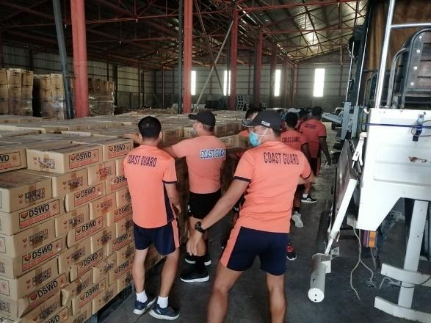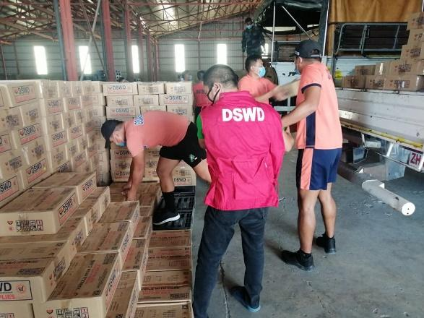

Unloading of NFA rice from NFA Aringay and NFA San Juan, La Union, and NFA Lingayen, Pangasinan

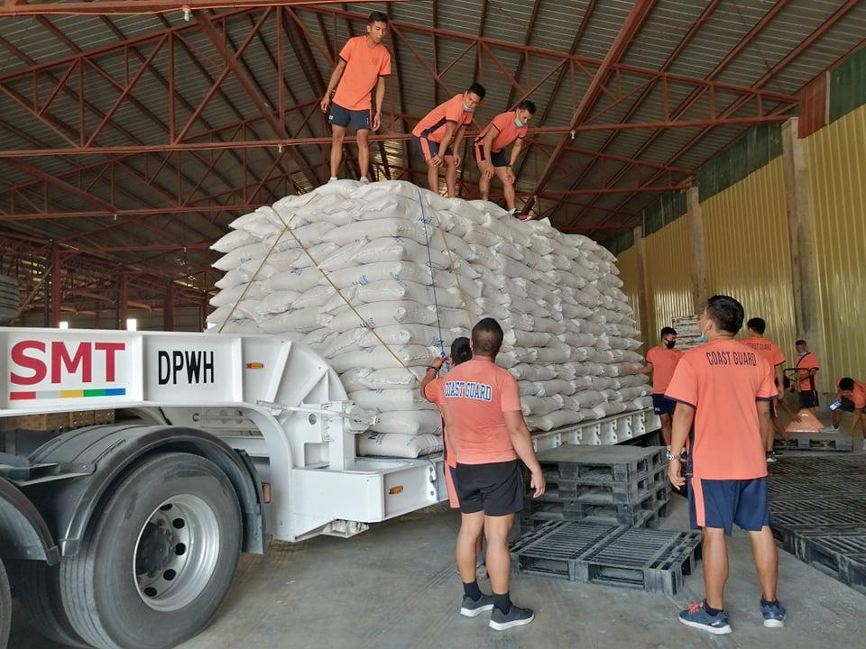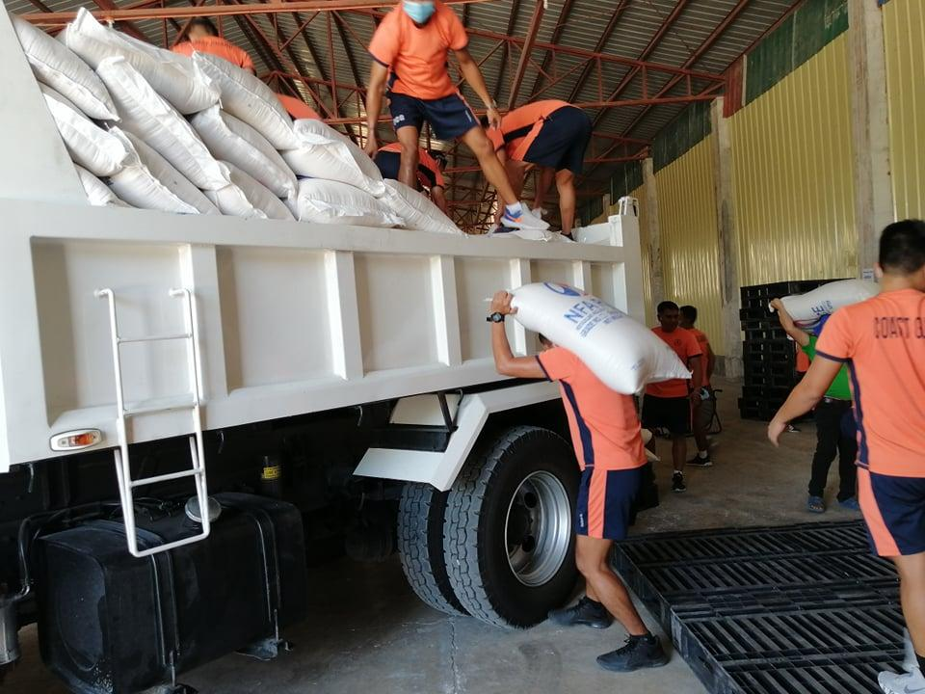

**DSWD-FO VI**

Delivery of family food packs for pre-positioning

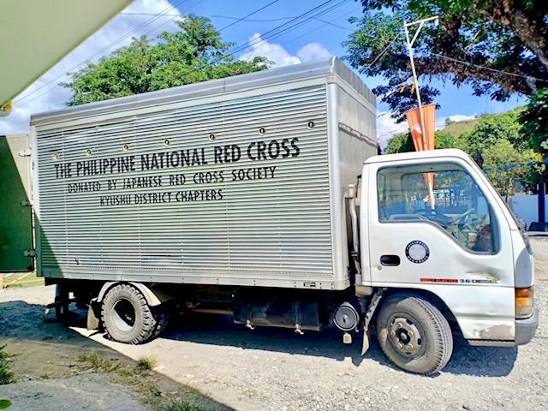

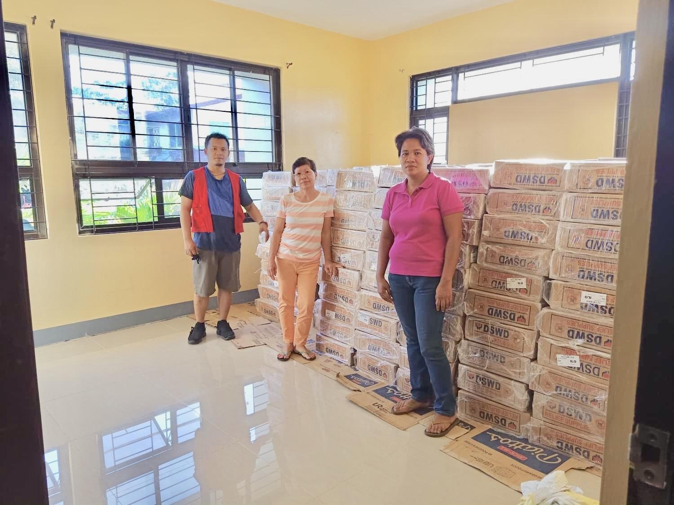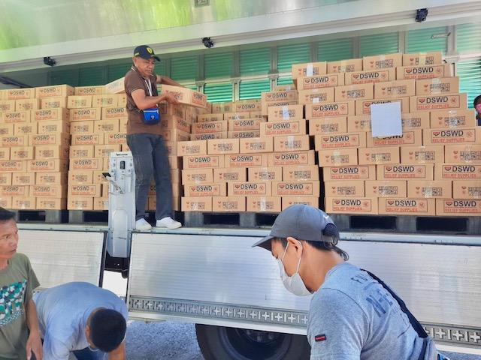

**DSWD-FO VII**

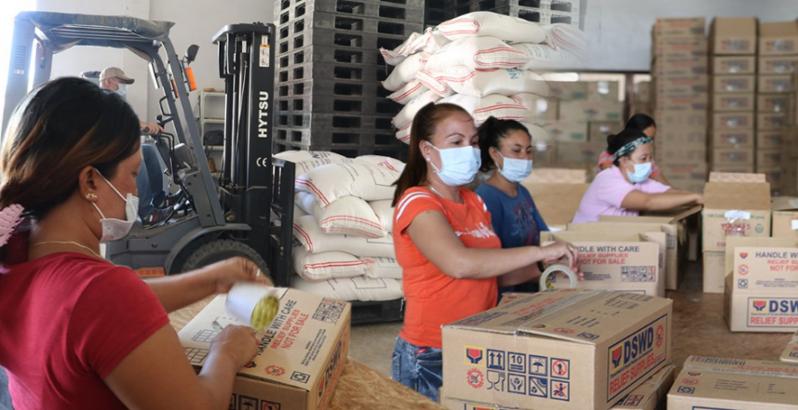

As of 20 March at 1700H, stockpile status is **22,120** **family food packs (FFPs)** amounting to **P7,963,200.00.**

Re-packing of goods is on-going in the three warehouses located in Cebu City, Bohol and Negros Oriental utilizing the 35 Pantawid beneficiaries under the Cash-for-Work Program.

Procurement is on-going for more raw materials using DSWD-FO P6.6M standby funds. An additional P26M was already requested from the Central Office in order to produce at least 60,000 more family food packs.

On 14 March, DSWD City Action Team in Lapulapu City distributed food packs as response to the request of the City government for the provision of assistance to displaced workers in 14 barangays due to the COVID-19 scare. 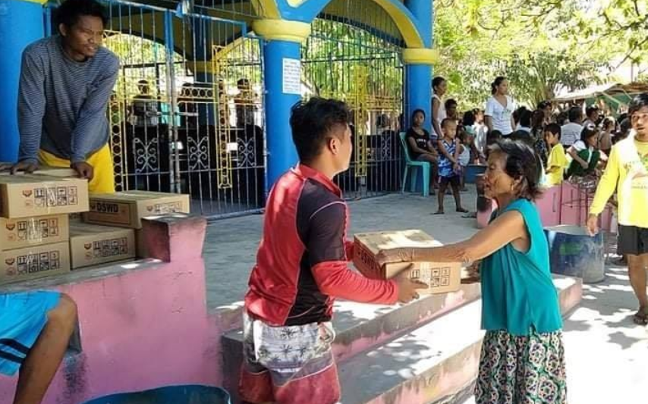

**DSWD initially released 2,619 family food packs or P942,840.00 worth of assistance.**

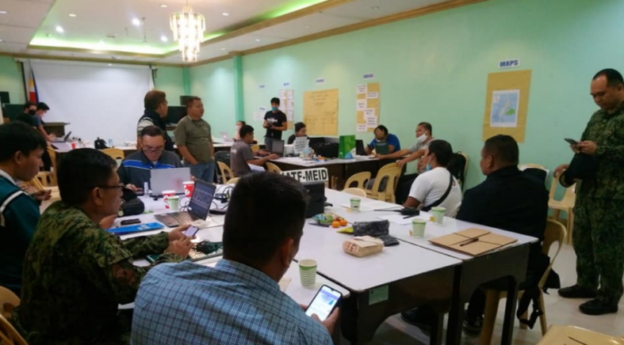

DSWD-7 takes part in the Joint IATF-MEID and RDRRMC7 Emergency Operations Center for COVID-19. The EOC was established at the DOH Regional Office and became operationalized yesterday, 21 March (photo taken from the official Facebook page of OCD-7).

Personnel from the DSWD’s Disaster Response Management Division takes turn in manning the EOC together with other RDRRMC7 members.

DSWD-7’s participation/attendance to coordination meetings called by the Inter-Agency Task Force on Managing Emerging Infectious Diseases (IATF-MEID7), Regional DRRM Council 7 (RDRRMC7) and special meetings by the Cebu Provincial Office and the Office of the Presidential Assistant for the Visayas (OPAV) Secretary Michael Lloyd Dino.

On Friday, 20 March, the Ceremonial Signing of the Joint Response Plan of IATF-MEID7 - RDRRMC7 for Management of Emerging Infectious Diseases for Central Visayas 2020 was held at DOH-7 Conference hall in Cebu City. 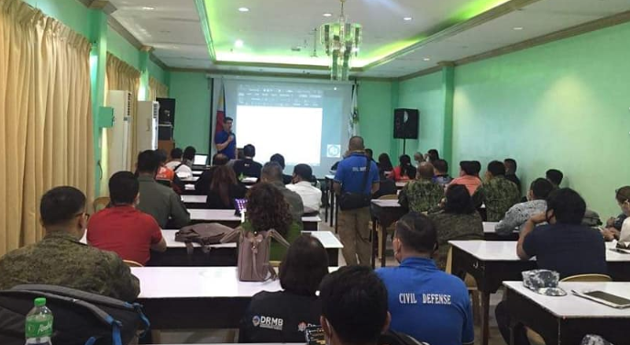

DSWD-7 was represented by Josephine Belotindos, Chief of the Disaster Response Management Division (DRMD).

On 17 March, a coordination meeting was organized by the IATF-MEID7 and RDRRMC7 re Presentation on Draft Joint Response Plan of IATF-MEID7-RDRRMC7 for Management of Emerging Infectious Diseases for Central Visayas 2020. 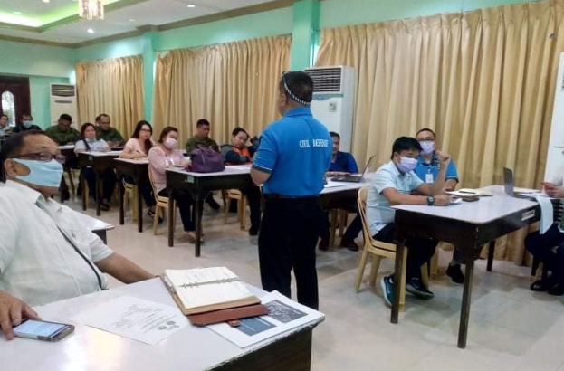

On 16 March, DSWD-7 RD Rebecca Geamala attended a meeting called for by the Presidential Assistant for the Visayas Secretary Michael Lloyd Dino on the readiness of the Response Cluster for COVID-19. RD Geamala assured OPAV that DSWD has prepared sufficient food packs, and more had already been procured and ready to be individually packed by the DSWD personnel (photo taken from the official Facebook page of OPAV). 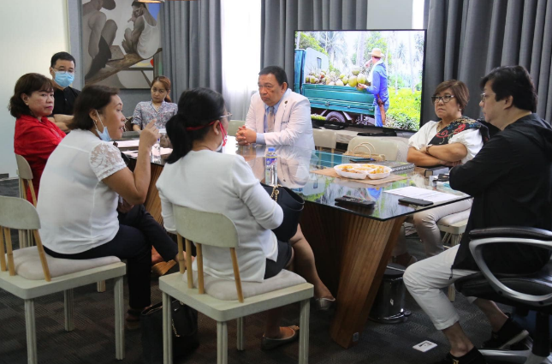

**DSWD-FO IX**

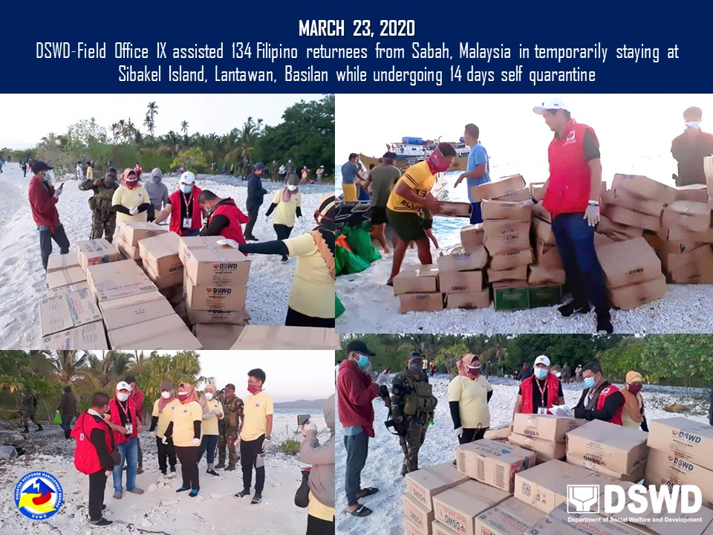

1. Statistics for the poor household is based on DSWD Listahanan 2016.